RTI Direct - Refresher Session 10/16/2017
By Kyle O’Toole 3:45-4:45pm
My RTI Direct ID: ________________________________

Signing In To RTI Direct
- Sign in at www.RTImdirect.com, enter User ID and Password.

Finding Students on RTI Direct
- Use search RTI direct search bar on top right to locate student by last name:
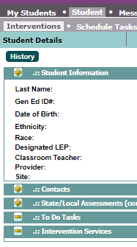
- Click on students name to see “Student Details”
  - Name, ID #, birthday, grade... etc.
  - Click the + next to “student information” to expand the box
- Stay in the “Interventions” Tab in the lighter gray bar.

Adding An Active Intervention
*Adding an intervention is a way to add an overall goal that you are working on with a student for that RTI cycle to the student’s profile.
- Move down to “Intervention Services”
  - Click “New Intervention” on the right side of the “intervention services” bar” bar.
- Complete all areas with red asterisks
  - School year
  - Intervention Area
  - Intervention
  - Start/End Date for your RTI cycle
  - Mode: in-class/ small group..etc
Follow the “intervention services” bar all the way over to find the “new intervention” button
  - Freq and Duration (how many times per week?)
  - Scheduled: within the school day
  - Decision: continue services
  - Status: MUST BE ACTIVE.
  - Grade
  - Provider- scroll down and find your name
  - Classroom Teacher- find your name again!
  - Administrator: Kelly Galullo
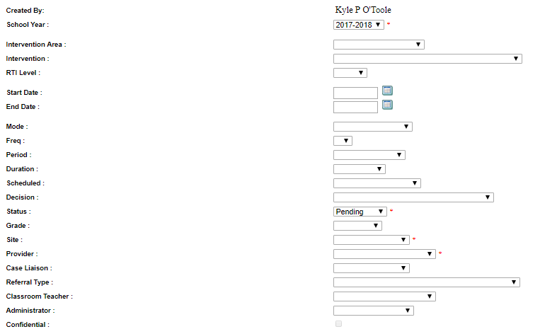
I am sure you can’t read the text in this photo. Just be able to recognize this general layout when it comes up on RTI Direct!

- If you see a space that asks for FUNDING- always use the “Local” option. Ignore the percentage box.
- Add BRIEF information for:
  - Reason/Criteria for Services
  - Consequences of Not Achieving
  - Intervention Curriculum (Goal and Interventions Strategy)
  - Planned Assessment to Monitor Progress Method (drop down box!)
  - Internal Comments if needed.
- Click Save and Return
  - Congratulations! You just entered an intervention for a student!
  - You’re an RTI Direct Rock Star!

Adding To The Document Repository
- Scan a document on the copy machines, send it to yourself via the email option on the copy machine. This will create a PDF version for you.
- Follow the previous steps to search for a student and get to their student detail page.
- Click on the “Document Repository” Tab in the light gray bar
- Click on the TINY “Add” button all the way over to the right side of the page. It is next to a question mark button.
- A New pop-up window will open called “Upload Document”
  - Check off the “Upload” (not fax)
  - Click Browse and find your Document from your computer
  - Fill in:
    - Document Title
    - Document Date
    - Description
    - Category (Drop down box)
  - Click SUBMIT!
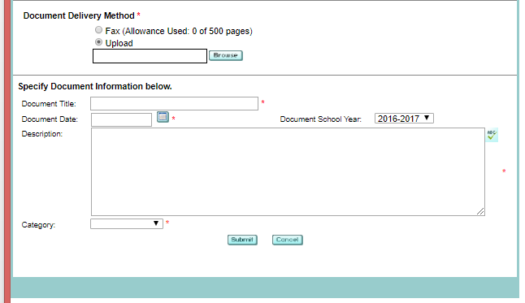
  - Return to Doc Repository or Upload More Documents?
- All uploaded Documents are viewable from the Document Repository main page.
- Congratulations! You just uploaded a document to the repository. You’re an RTI Direct ROCK STAR!

Adding To The Service Log
A service log is a way to log specifics of when you meet with a student and what you worked on.
- Follow the previous steps to search for a student and get to their student detail page.
- Stay on the “Interventions” Tab in the light gray bar

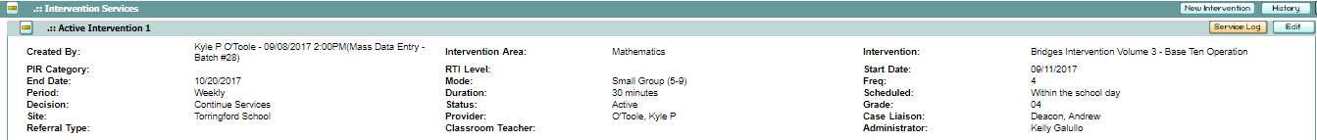
- Press the + symbol on the Intervention Services Bar
  - Press the + symbol on the “Active Intervention” to which you wish you add a service log.
- Click “Service Log”
  - You will see a list of all logs for that student during this particular active intervention.
  - Click “Add” to add a new service log.
  - You will be prompted to add information for :
    - Date
    - Provider
    - Minutes
    - Comments
  - SAVE!
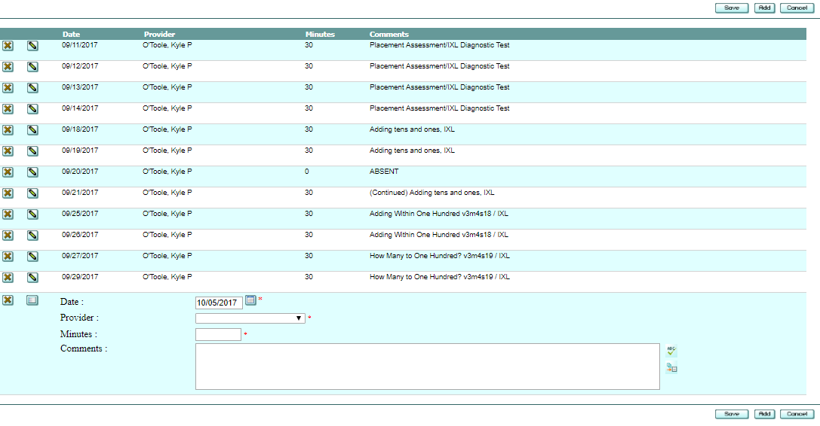

- Congratulations! You just added a service log to an active intervention.
- You’re an RTI Direct Rock Star!

RTI Direct - Refresher Session 10/16/2017
By Kyle O’Toole 3:45-4:45pm
Exit Survey
**Please rip this page out, complete survey, and pass in to Kyle. THANK YOU!

- Was this session helpful?
- Did you feel welcomed at this session?

- Did you learn anything new?

- What features were new to you?

- How confident do you feel at using RTI Direct?

- Comments/Additional Questions:

